**Raga Ranjini R (19001198)**

Task 10 – April20

OUTPUT SCREENSHOTS:

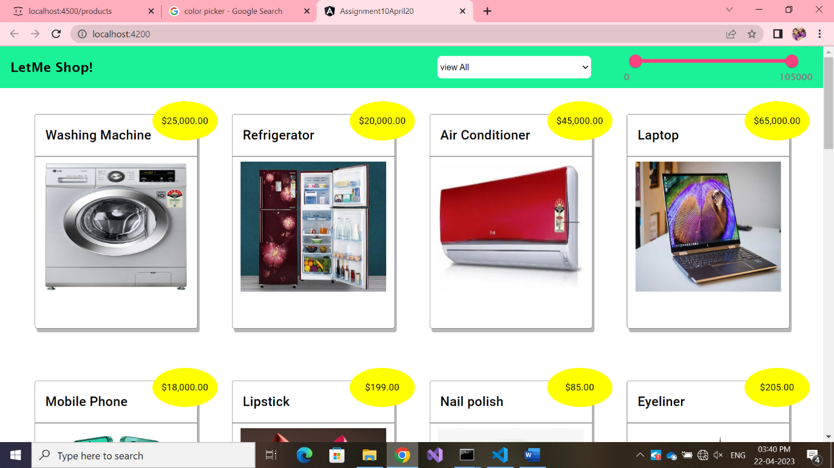

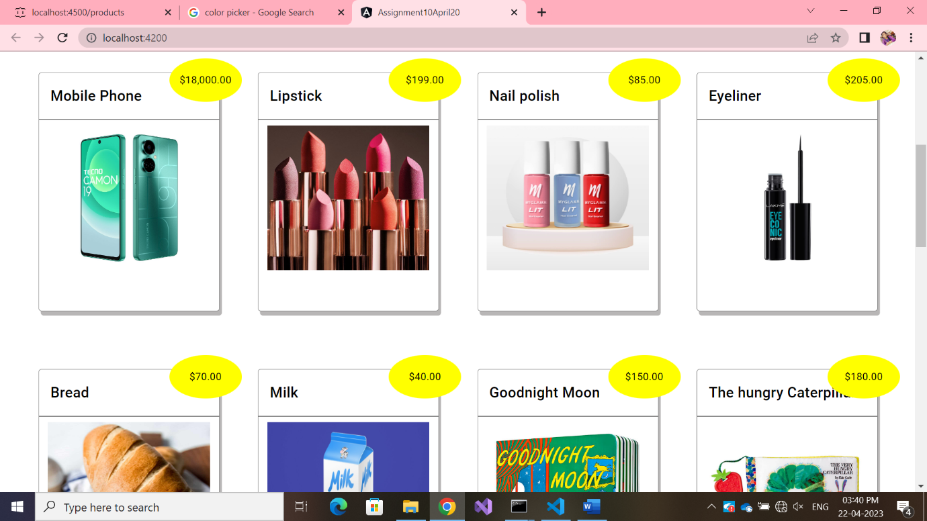

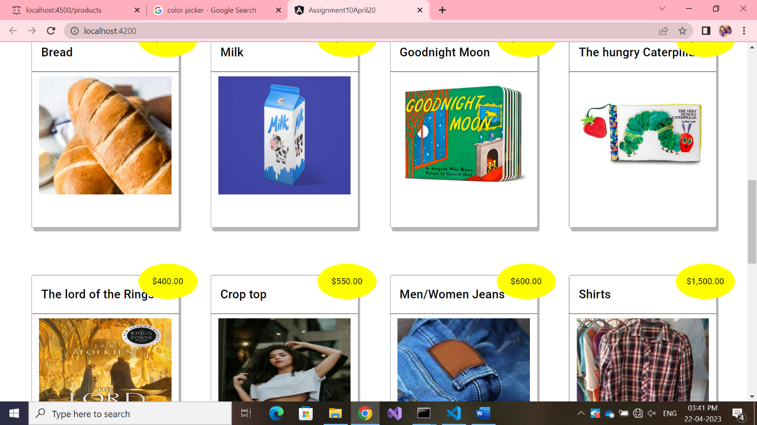

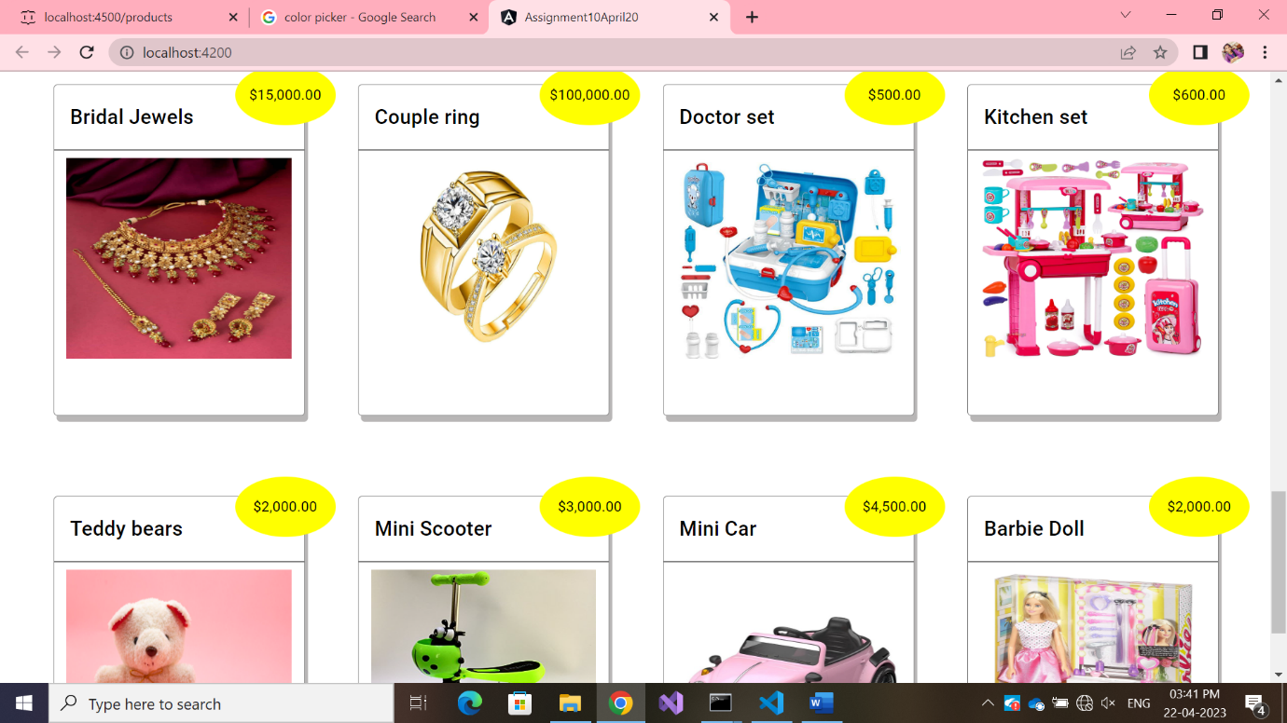

TYPE-FILTER – WORKING:

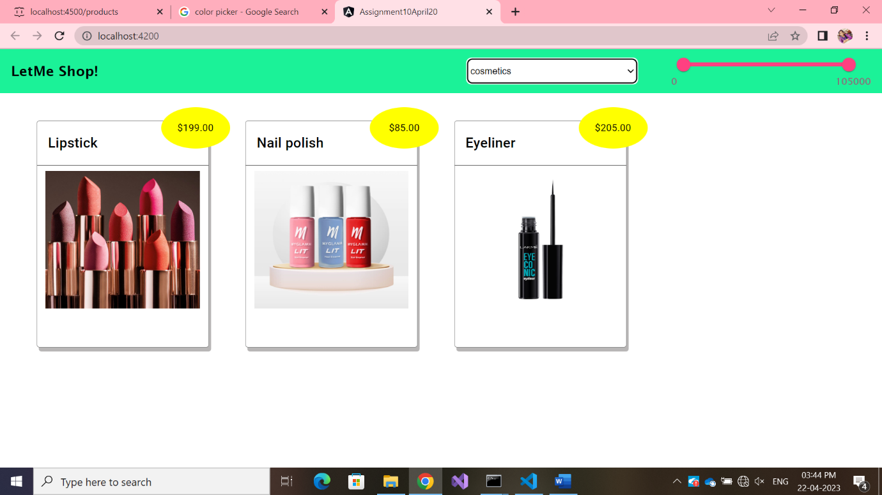

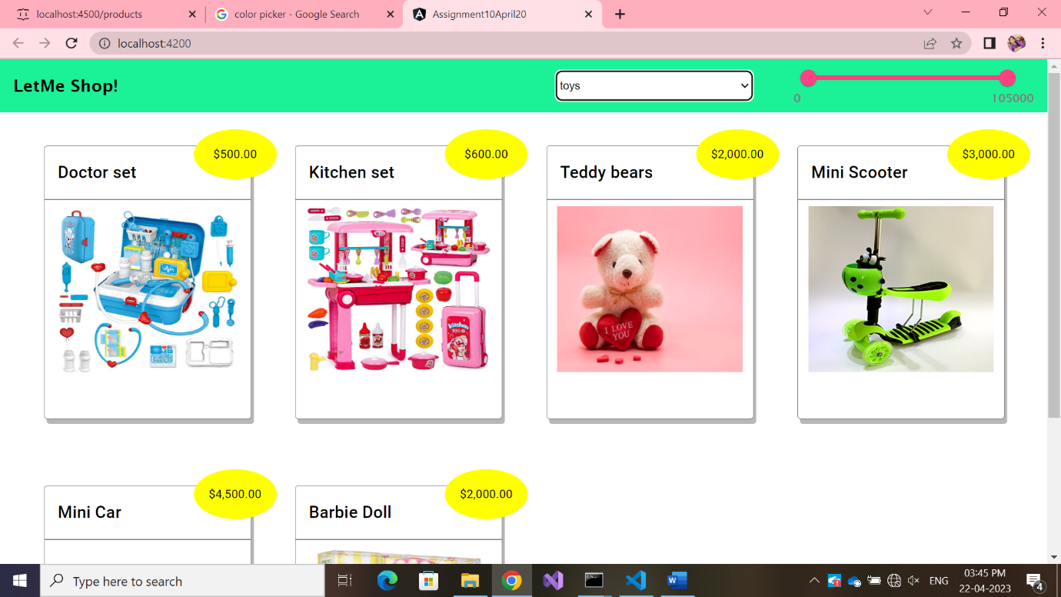

PRICERANGE-FILTER-WORKING:

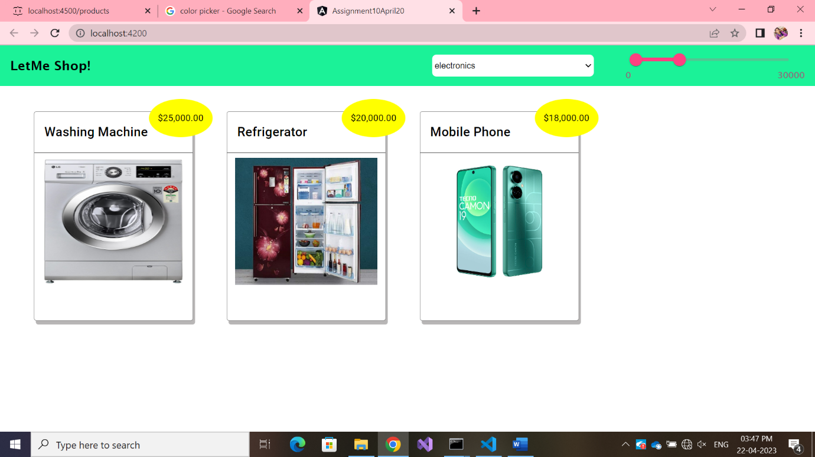

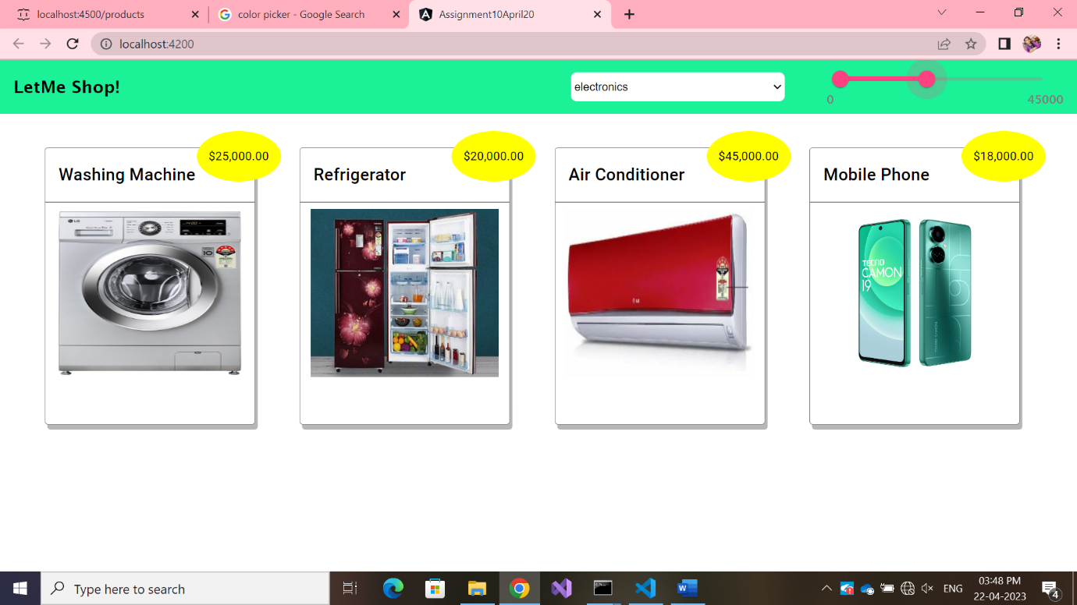

HOVERING-EFFECTS:

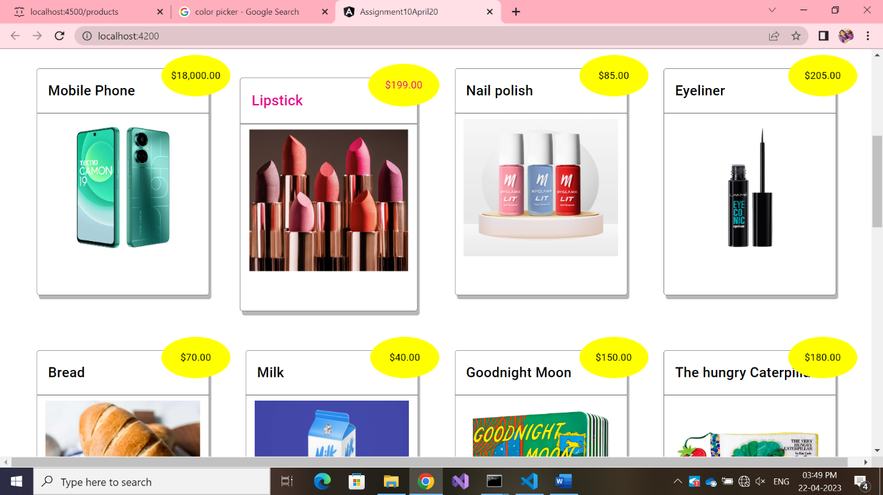

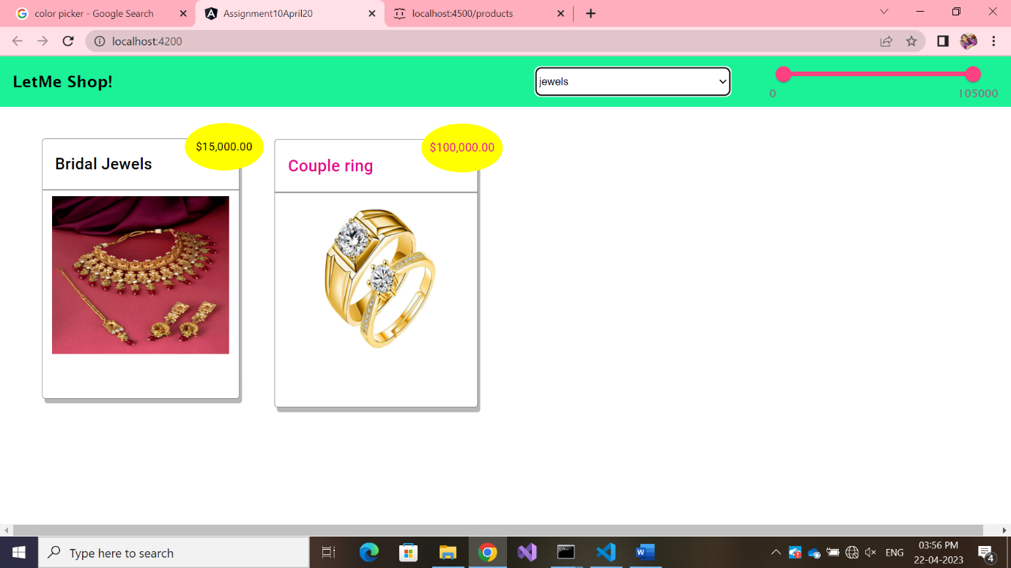

* Card zoom-in a bit
* Text color changes to pink

FLOW DIAGRAM:

<app-body>

<app-home>

*home.component.html*

<app-root>

*app.component.html*

*index.html*

*filter.pipe.ts*

mat-card(products)

productslist[]

data

{Child Component}

*body.component.ts*

*body.component.html*

mat-toolbar (menubar)

getProducts()

*get-products.service.ts*

{Parent Component}

*home.component.ts*